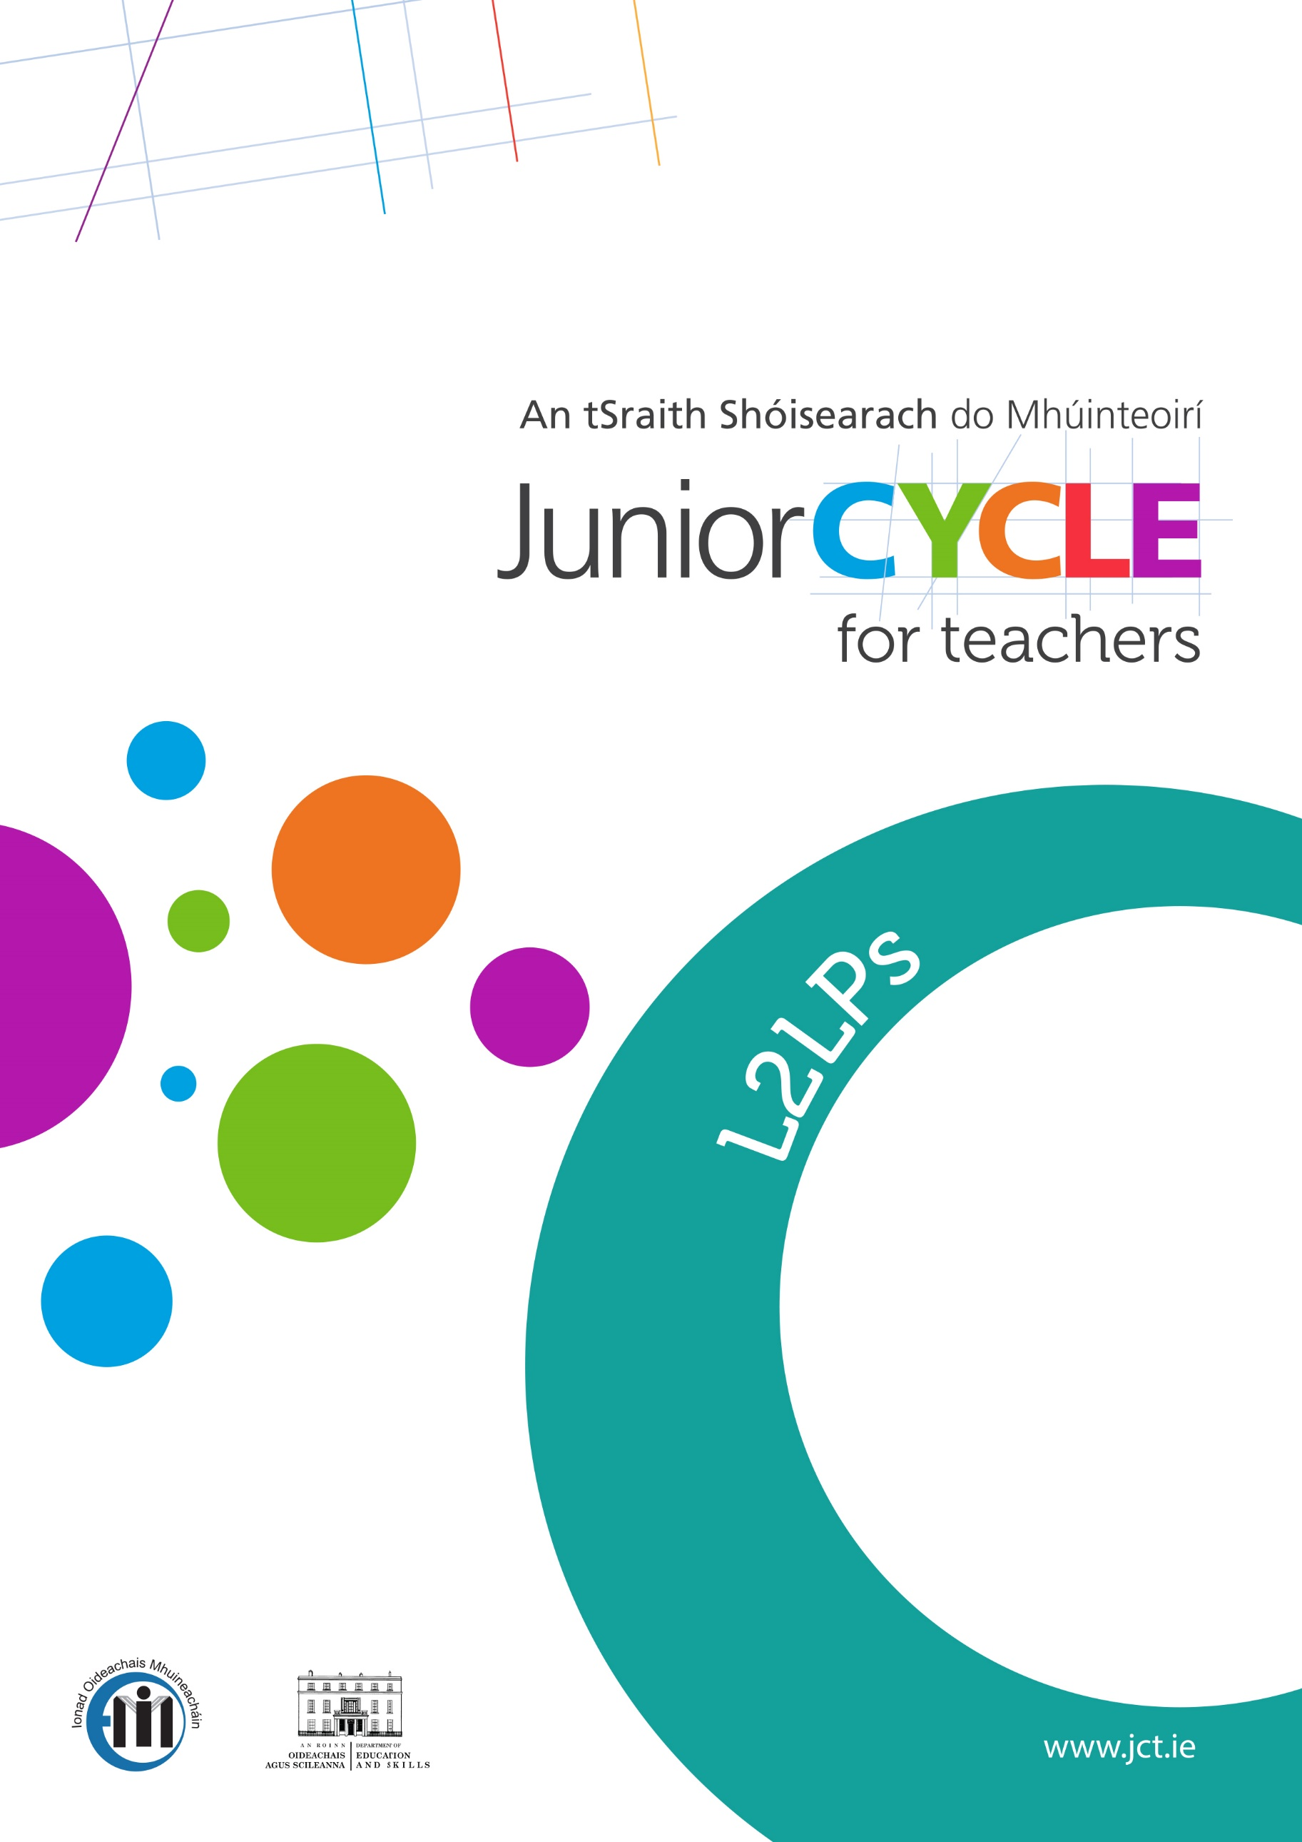

Sample Timetable/Planning Booklets
(M)

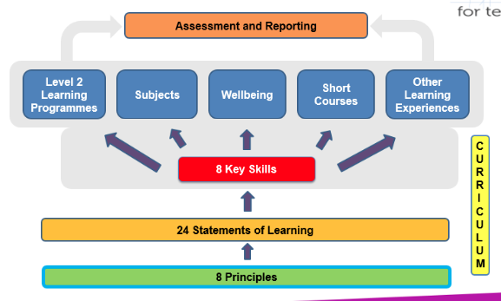

Sample – Yearly Plan. 4 Year Programme. Year 1
 | Communication & Literacy | Numeracy | Personal Care | Living in the Community | Preparation for Work | Short Course
Term 1 | - Speaking appropriately for a variety of purposes and demonstrating attentiveness as a listener  - Using expressive arts to communicate  - Using non-verbal behaviour for a variety of purposes: | - Developing an awareness of number  -Managing Money  -Using a calculator | - Developing good daily personal care: | – Developing good relationships | – Being able to set goals for learning
Term 2 | - Reading to obtain basic information  - Using expressive arts to communicate  - Using a range of writing forms to express opinions | - Developing an awareness of time | - Developing healthy eating habits | –Resolving conflict | – Being able to set goals for learning
Term 3 | - Using expressive arts to communicate  -Using Information and communication technology for a range of purpose | - Using Shapes | - Becoming aware of one’s sexuality | – Using Local facilities | – Being able to set goals for learning

Teacher to pick outcomes to follow for class and/or individual students.
Year 2
 | Communication & Literacy | Numeracy | Personal Care | Living in the Community | Preparation for Work | Short Course
Term 1 | - Speaking appropriately for a variety of purposes and demonstrating attentiveness as a listener  - Using expressive arts to communicate  - Using non-verbal behaviour for a variety of purposes | - Developing an awareness of number  -Managing Money  -Using a calculator | -Developing a healthy lifestyle | – Developing good relationships | -Finding out about work
Term 2 | - Reading to obtain basic information  - Using expressive arts to communicate  - Using a range of writing forms to express opinions | - Developing an awareness of Temperature  -- Developing an awareness of time | - Being able to manage stress | –Resolving conflict | -Finding out about work
Term 3 | - Using expressive arts to communicate  -Using Information and communication technology for a range of purpose | -Developing an awareness of weight and capacity | - Becoming aware of one’s sexuality | -Seeking help and advice | -Finding out about work
Year 3
 | Communication & Literacy | Numeracy | Personal Care | Living in the Community | Preparation for Work | Short Course
Term 1 | - Speaking appropriately for a variety of purposes and demonstrating attentiveness as a listener  - Using expressive arts to communicate  - Using non-verbal behaviour for a variety of purposes | - Developing an awareness of number  -Managing Money  -Using a calculator | - Developing good daily personal care | – Developing good relationships | – Preparing for a work related activity  -Taking part in a work related activity
Term 2 | - Reading to obtain basic information  - Using expressive arts to communicate  - Using a range of writing forms to express opinions | -Developing an awareness of length and distance  -Developing an awareness of time | -Knowing how to stay safe | –Resolving conflict | – Preparing for a work related activity  -Taking part in a work related activity
Term 3 | - Using expressive arts to communicate  -Using Information and communication technology for a range of purpose | - Developing spatial awareness | -Becoming aware of one’s sexuality | -Making consumer choices | – Preparing for a work related activity  -Taking part in a work related activity

Year 4
 | Communication & Literacy | Numeracy | Personal Care | Living in the Community | Preparation for Work | Short Course
Term 1 | - Speaking appropriately for a variety of purposes and demonstrating attentiveness as a listener  - Using expressive arts to communicate  - Using non-verbal behaviour for a variety of purposes | - Developing an awareness of number  -Managing Money  -Using a calculator | -Making personal decisions | – Developing good relationships | -Developing an awareness of health and safety using equipment  -Taking part in a work related activity | Choice 1
Term 2 | - Reading to obtain basic information  - Using expressive arts to communicate  - Using a range of writing forms to express opinions | -Using data for a range of purposes | - Recognising Emotions | –Resolving conflict | -Developing an awareness of health and safety using equipment  -Taking part in a work related activity
Term 3 | - Using expressive arts to communicate  -Using Information and communication technology for a range of purpose | -Developing an awareness of time | -Becoming aware of one’s sexuality | -Making Consumer choices | -Developing an awareness of health and safety using equipment  -Taking part in a work related activity
SAMPLE YEARLY PLAN broken into TERMLY plans- TERM ONE
Communication & Literacy | Numeracy | Living in the Community | Personal Care | Preparing for Work
Speaking appropriately for a variety of purposes and demonstrating attentiveness as a listener | Managing money | Seeking Help and advice  D1. Name the relevant agencies that offer our support and advice to the public | Being able to manage stress  D1. Describe school/community/personal situations that are stressful | Preparing for a work related activity  C1. Identify and list their own talents, strengths
A1. Listen to obtain information relating to more than one option | A1. Recognise frequently used Euro notes and coins
A2. Ask questions obtain information | A2. Pay for an item correctly and count the change in a mock-up or real life shopping transaction | D2. Describe the schools procedure to report an incident | D2. Recognise some of the signs of stress | C2. Create a curriculum vitae including personal profile, education and work experience details
A3. Follow a series of spoken instructions under supervision | Developing an awareness of number | D3. Compile a short list of people or groups who can provide support, including personal contacts and group/organisations | D3. Identify some ways to relax | C3. Participate in a short interview
 | B1. Recognize numbers up to 100 in Numeral form
A4. Express personal opinions, facts and feelings appropriately | B2. Recognize place value in relation to units, tens and hundreds | D4. Describe how to contact a range of people or organisations in their local area that can provide help and advice | D4. Demonstrate a relaxation technique | C4. Keep a punctuality and attendance record for a month
A5. Participate in practical formal and informal communications | Developing an awareness of temperature | D5. Visit a local community organisation and ask for advice | D5. Practise a range of relaxation techniques in real life circumstances | C5. Carry out specific tasks in a range of roles in school
 | C1. Use appropriate words to describe temperature
Using non-verbal behaviour for a variety of purposes | C2. Identify instruments used for indicating and adjusting temperature |  | D6. Identify a range of situations in which ability to relax has been helpful | C6. Keep a record of tasks completed in a journal
B1. Identify a range of non-verbal communication methods | C4. Compare temperatures for the different times of the year
B2. Use appropriate non-verbal behaviour in communication a simple idea | C5. Locate appropriate temperatures on a cooker dial
B4. Respond to non-verbal signals and signs encountered in daily life | Developing an awareness of time
 | J5. Find a specified day or date on a calendar or timetable
B5. Follow the sequence of non-verbal instructions or directions for a frequent activity | J6. Match months or activities with their seasons

TERM TWO
Communication and Literacy | Numeracy | Living in the Community | Personal Care | Preparing for Work
Reading to obtain basic information: | Managing money  A5. Recognise the difference between using money to buy essential items and luxury items | Using Local Facilities C1. List ways of spending leisure time | Becoming aware of ones sexuality  F1. Identify the standard names of the sexual organs | Taking part in a work related activity
C1. Read familiar words that are commonly used and personally relevant
C3. Interpret different forms of writing and text, including social sight signs and symbols | A6. Plan a personal budget for a week | C2. Identify familiar places and organisations in the local community. | F2. Describe the functions of the sexual parts of the body | One of the below:  Horticulture  Mini-enterprise  Plan a school function  Organise a day trip
Developing an awareness of number
B3. Add two digit whole numbers that total less than 100 in the context of an everyday situation
C4. Find key information from different forms of writing | B4. Subtract two digit whole numbers in the context of an everyday situation | C3. Distinguish between what is free and what has to be paid for in the community | F3. Recognise the physical and emotional changes which occur in boys and girls during adolescence
 | B5. Estimate quantities to nearest value of in broad terms
Develop an awareness of weight and capacity
D1. Use appropriate vocabulary to describe the units of weight and capacity
Using a range of writing forms to express opinions | D2. Identify the marks for the units of weights and capacity | C4. Participate in a school-based community project and record their participation, e.g. a litter campaign | F4. Recognise the difference between appropriate and inappropriate ways of expressing feelings
D1. Write/type notes and messages needed for simple tasks | D3. List some examples of weight and capacity from daily life
 | D4. Use a graduated vessel to work out the capacity of liquids
D2. Write/type at least five sentences so that they convey meaning or information | D5. Use a weighing scales to work out the weight of powders and solids |  | F5. Recognise the difference between a friendship and a more intimate relationship
 | Developing an awareness of time J1. Tell the time from an analogue clock for the hour, half hour, and quarter hour
D6. Use a range of different forms of writing to suit purpose and audience | J3. Identify the key times during the day, on the hour, half hour, quarter hour
TERM THREE
Communication and Literacy | Numeracy | Living in the Community | Personal Care | Preparing for Work
Using information and communication technologies | Managing money  A7. Save a small amount of money each week to buy an item | Resolving Conflict  B1. Describe what peer pressure is, give examples of peer pressure and suggest ways to handle it | Knowing how to stay safe  E1. Identify key safety risks in the workplace/home/community | One of the below:  Horticulture Mini-enterprise Plan a school function Organise a day trip
F2. Use technology requiring not more than three functions, for personal, home and educational/workplace
F5. Turn a personal computer on and off safely | Developing an awareness of number  B4. Subtract two-digit whole number s in the context of an everyday situation | B2. Describe ways of handling peer pressure | E2. Recognise when personal safety is threatened, e.g. bullying/harassment
F6. Identify the information symbols on a desktop
F7. Use frequently used keys appropriately | B5. Estimate quantities to the nearest value in broad terms
F8. Use a software package, involving opening a package, entering and manipulating text/image/data, save to file, print and exit safely
F9. Access a range of websites on the internet | Develop an awareness of length  E2. Identify the units of length and distance on a ruler, metre stick, and measuring tape | B3. Demonstrate an ability to negotiate with peers | E3. Name daily practices that promote personal safety, e.g. using pedestrian crossings, disconnecting electrical equipment at night, pouring hot liquids in after cold, wearing protective clothes/gloves, seeking advice
F10. Find information for a project on the web | E3. Use a ruler to draw and measure different lengths of lines
F11. Send and open an email | E5. Measure the length of common places | B4. Describe the characteristics of bullying behaviour | E4. Describe appropriate response when a risk is identified
Using expressive arts to communicate | Developing an awareness of time J2. Tell the time from a digital clock for the hour, half hour, quarter hour | B5. Identify the schools approach to dealing with bullying behaviour
E1. Participate in a performance or a presentation | J4. Solve problems to work out the passage of time | B6. Identify the steps for dealing with conflict
E2. Create a range of images using a variety of materials
E3. Produce a piece of work for display

 | 9.00 | Class 1 | Class 2 | Class 3 | Break | Class 4 | Class 5 | Class 6 | Lunch | Class 7 | Class 8 | Class 9
Monday | Tutor  Rm 30 | ESS  Geography  Mr. Farrelly  R31 | Living in the Community  Ms. Flood  R8 | Caring for Animals  Ms. Maguire  R8 |  | English  D. Middleton  R40 | Subject Support  Ms. Middleton | Personal Care (Social)  Ms. Flood  R8 |  | Maths  Mr. Stone  R 42 | SPHE  J. Potter  R1 | Irish Studies/ECDL  Mr. Waters  R30
Tuesday | Tutor  Rm 30 | Mr. Stone  Maths  R 42 | Ms. Middleton  Religion  R40 | Caring for Animals  Ms. Maguire  R8 |  | Personal Care(Healthy Lifestyle)  Ms. Maguire  R8 | Irish Studies/ECDL  Mr. Water’s R 30 | English  Ms. Middleton  R 40 |  | P.E | P.E | ESS  History  Ms. Needham  R 30
Wednesday | No  Tutor  Class | English  D. Middleton  R40 | C.S.P.E  J. Potter  R 1 | Woodwork  M. Waldron  R 4 |  | Caring for Animals  Ms. Maguire  R 8 | Living in the Community  Ms. Flood  R 8 | Mr. Stone  Maths  R 42
Thursday | Tutor  Rm 30 | Personal Care(Social)  Ms. Flood  R 8 | Mr. Stone  Maths  R 42 | ESS  History  Ms. Needham  R 30 |  | Woodwork  M. Waldron  R4 | Woodwork  M. Waldron  R 4 | English  Ms. Middleton  R 40 |  | LIC  Ms. Ryan  R 8 | Preparing for  Work  Ms.Ryan  R 8 | Irish Studies/ECDL  Mr .Waters  R30
Friday | Tutor  Rm 30 | Woodwork  M. Waldron  R 4 | Review of week/Goal setting  Ms. Flood  R 8 | Caring for Animals  Ms. Maguire  R 8 |  | Caring for Animals  Ms. Maguire  R 8 | Irish Studies/ECDL  Mr.Waters  R30 | Mr. Stone  Maths  R 42 |  | K. Galvin  Science  R 12 | English  D. Middleton  R 40
2nd Year Student studying a mix of Level 2 and Level 3 subjects

Support | L2LPs (including short course) taught outside of class
PLUs taught as part of mainstream subject class | Specific learning objectives decided on by subject department taught in class
Small Group Level 3 subject (as alternative to History and Geography) | Level 3 subjects (mainstream classes)
Class for all students with Irish Exemptions-broken into 1 day Irish studies 1 day ECDL/Computers 2 days support or EAL

Sample general overview timetable First Year student

Student A – A first year student with a diagnoses of mild general learning disabilities. He will follow a reduced curriculum and will undertake five subjects at Junior Certificate Level 3, in a mainstream setting, (English, Maths, History, Geography, Business and CSPE). During the remainder of the time he will be withdrawn from mainstream and will be working on elements of the PLU’s, either on a 1:1 basis or in small groups.
Student A | Monday | Tuesday | Wednesday | Thursday | Friday
9.00 – 9.10 | Tutorial | Tutorial | Tutorial | Tutorial | Tutorial
9.10 – 9.50 | CSPE | Communication & Literacy | Personal Care | Living in a Community | Communication & Literacy
9.50 – 10.25 | Maths | Living in a Community | Maths | Living in a Community | Numeracy
10.25 – 11.00 | Short Course | English | Numeracy | Living in a Community | Numeracy
11.00 – 11.15 | Break | Break | Break | Break | Break
11.15 – 11.55 | Geog | Personal Care | Business | English | Art
11.55 – 12.30 | Personal Care | Geog | Communication & Literacy | Maths | Maths
12.30 – 13.05 | Business | Home Ec | English | Social Skills | English
13.05 – 13.45 | Lunch | Lunch | Lunch | Lunch | Lunch
13.45 – 14.20 | History | Home Ec | Preparing for Work | History | Short Course
14.20 – 14.55 | Preparing for work | Preparing for Work | Personal Care | Preparing for  Work | Short Course
PLEASE NOTE THESE TIMETABLES DO NOT REFLECT MOVE TO MINIMUM 40 MINUTE CLASSES

Student A | Monday | Tuesday | Wednesday | Thursday | Friday
9.00 – 9.10 | Tutorial | Tutorial | Tutorial | Tutorial | Tutorial
9.10 – 9.50 | CSPE | Communication & Literacy  Speaking appropriately for a variety of reasons | Personal Care  Making personal decisions | Living in a Community  Using local facilities | Communication & Literacy  Using non-verbal behaviour to get the message across
9.50 – 10.25 | Maths | Living in a Community  Developing good relationships | Maths | Living in a Community  Seeking help & advice | Numeracy  Develop an awareness of number
10.25 – 11.00 | Short Course  Caring for Animals | English | Numeracy  Using a calculator | Living in a Community  Organise a day trip | Numeracy  Develop an awareness of time
11.00 – 11.15 | Break | Break | Break | Break | Break
11.15 – 11.55 | Geography | Personal Care  Recognising Emotions | Business | English | Art
11.55 – 12.30 | Personal Care  Developing a healthy lifestyle | Geography | Communication & Literacy  Using suitable technologies for a range of purposes | Maths | Maths
12.30 – 13.05 | Business | Home Ec. | English | Social Skills  Being able to manage stress | English
13.05 – 13.45 | Lunch | Lunch | Lunch | Lunch | Lunch
13.45 – 14.20 | History | Home Ec. | Preparing for Work  Mini-Company | History | Short Course  Caring for animals
14.20 – 14.55 | Preparing for work  Being able to set goals for learning | Preparing for Work  Preparing for a work related activity | Personal Care  Making personal decisions | Preparing for work  Finding out about work | Short Course  Caring for animals
PLEASE NOTE THESE TIMETABLES DO NOT REFLECT MOVE TO MINIMUM 40 MINUTE CLASSES

Student B – A first year student who is borderline functioning within the moderate range of general learning disabilities. He will not be undertaking any final exams in Junior Cycle subjects at Level 3, but will experience some mainstream classes and subjects. During his time in mainstream subject classes he will be working on elements from different PLU’s. During the remainder of the time he will be withdrawn from mainstream and will be working on elements of the PLU’s, either on a 1:1 basis or in small groups.
Student B | Monday | Tuesday | Wednesday | Thursday | Friday
9.00 – 9.10 | Tutorial | Tutorial | Tutorial | Tutorial | Tutorial
9.10 – 9.50 | CSPE | SPHE | Religion | Music | Communication & Literacy
9.50 – 10.25 | Maths | Living in a Community | Maths | Music | Numeracy
10.25 – 11.00 | Short Course | English | Numeracy | Living in a Community | Numeracy
11.00 – 11.15 | Break | Break | Break | Break | Break
11.15 – 11.55 | PE | Personal Care | Personal Care | English | Communication & Literacy
11.55 – 12.30 | PE | Metalwork | Communication & Literacy | Maths | Maths
12.30 – 13.05 | Communication & Literacy | Metalwork | English | Art | English
13.05 – 13.45 | Lunch | Lunch | Lunch | Lunch | Lunch
13.45 – 14.20 | Communication & Literacy | Woodwork | Preparing for Work | Art | Home Ec
14.20 – 14.55 | Living in the Community | Woodwork | Preparing for Work | Short Course | Home Ec
14.55 – 3.30 | Computers | Social Skills | Preparing for Work | Short Course | Preparing for work
PLEASE NOTE THESE TIMETABLES DO NOT REFLECT MOVE TO MINIMUM 40 MINUTE CLASSES

Student B | Monday | Tuesday | Wednesday | Thursday | Friday
9.00 – 9.10 | Tutorial | Tutorial | Tutorial | Tutorial | Tutorial
9.10 – 9.50 | CSPE  Resolving Conflict | SPHE  Be able to manage stress | Religion  Developing good relationships | Music  Using expressive arts to communicate | Communication & Literacy  Using non-verbal behaviour to get a message across
9.50 – 10.25 | Maths  Developing spatial awareness | Living in a Community  Developing good relationships | Maths  Develop an awareness of length and distance | Music  Using expressive arts to communicate | Numeracy  Develop an awareness of number
10.25 – 11.00 | Short Course  Caring for Animals | English  Reading to obtain basic information | Numeracy  Using a calculator | Living in a Community  Organise a day trip | Numeracy  Develop an awareness of time
11.00 – 11.15 | Break | Break | Break | Break | Break
11.15 – 11.55 | PE  Developing healthy eating habits | Personal Care  Recognising Emotions | Personal Care  Knowing how to stay safe | English  Speaking appropriately for a variety of purposes | Communication & Literacy  Using shapes / using expressive arts to communicate
11.55 – 12.30 | PE  Developing a healthy lifestyle | Metalwork  Developing an awareness of health and safety | Communication & Literacy  Using suitable technologies for a range of purposes | Maths  Managing Money | Maths  Using data for a range of purposes
12.30 – 13.05 | Communication & Literacy  Using a range of writing forms to express opinions | Metalwork Developing an awareness of health and safety | English  Reading to obtain basic information | Art  Using expressive arts to communicate | English  Using a range of writing forms to express opinion
13.05 – 13.45 | Lunch | Lunch | Lunch | Lunch | Lunch
13.45 – 14.20 | Communication & Literacy  Reading to obtain basic information | Woodwork  Developing an awareness of health and safety | Preparing for Work  Mini - Company | Art  Using Shapes | Home Ec.  Developing healthy eating habits
14.20 – 14.55 | Living in the Community  Using local facilities | Woodwork  Developing an awareness of health and safety | Preparing for Work  Making personal decisions | Short Course  Caring for animals | Home Ec.  Developing healthy lifestyles
14.55 – 15.31 | Computers  Using information and communication technology for a range of purposes | Social Skills  Recognising emotions | Preparing for Work  Being able to set goals for learning | Short Course  Caring for animals | Preparing for work  Preparing for a work related activity
PLEASE NOTE THESE TIMETABLES DO NOT REFLECT MOVE TO MINIMUM 40 MINUTE CLASSES

Sample Timetable of PLU’s - 250 hours per PLU and 100 hours per Short Course
09.00 | Assembly | Assembly | Assembly | Assembly | Assembly
09.20 | Communication & Literacy | Communication & Literacy | Communication & Literacy | Communication & Literacy | Communication & Literacy
09.50 | Numeracy | Numeracy | Numeracy | Numeracy | Numeracy
10.20 | Living in the Community | Personal Care | Preparing for Work |  | Personal Care
10.50 | Break | Break | Break | Break | Break
11.00 | Short Course 1 | Living in the Community |  | Personal Care | Preparing for Work
11.30 | Short Course 1 |  | Living in the Community |  | Living in the Community
12.00 | Religion | Religion | Religion | Religion | Religion
12.30 | Lunch | Lunch | Lunch | Lunch | Lunch
13.00 | Personal Care |  | Personal Care | Living in the Community
13.30 |  | Preparing for Work |  | Preparing for Work | Short Course 2
14.00 | Preparing for Work |  |  |  | Short Course 2
* Yellow indicates time slots that can be used towards other curricular activities as required for each class, e.g. Swimming, Speech Therapy, and Occupational Therapy.

