Principles of Junior Cycle 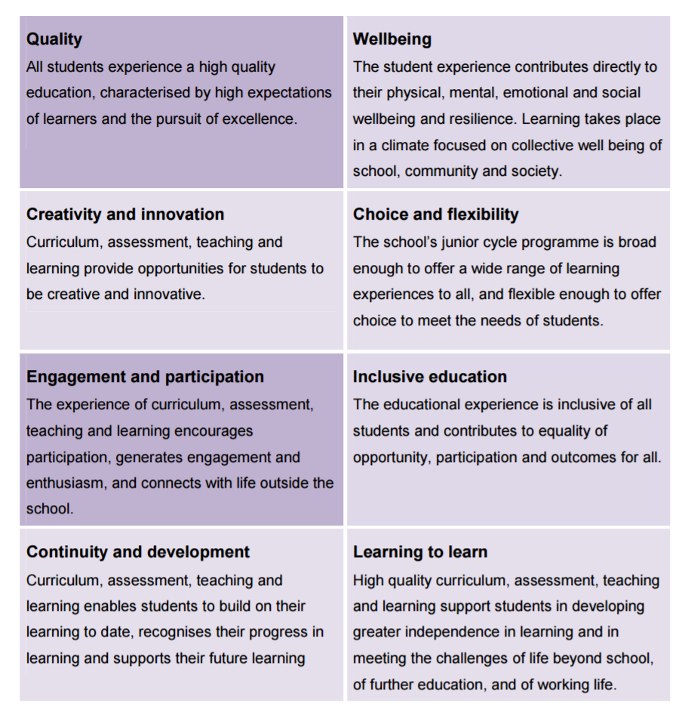

How do we implement the Principles in our school?

Quality | Wellbeing
Creativity and innovation | Choice and flexibility
Engagement and participation | Inclusive education
Continuity and development | Learning to learn

