**Numeracy**

**Subject**

**Communication and Literacy**

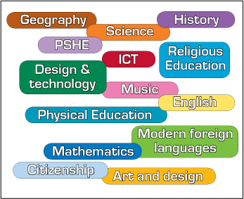

Which Level 2 Learning Outcomes can you teach in your subject area?

Full Programme

**Preparing for Work**

**Living in the Community**

**Personal Care**

**Numeracy**

**Subject**

**Communication and Literacy**



**Preparing for Work**

**Living in the Community**

**Personal Care**

Link to Subject Department Plan for

__________________­­­­­­­­­­­______ (Month/Term)

**Numeracy**

**Subject**

**Communication and Literacy**



**Preparing for Work**

**Living in the Community**

**Personal Care**

Full Programme/L2LP in Subject

Name of Student: _________________